Release Assembly - TopCoder Cockpit Reports Filter Panels Revamp Deployment Guide

Revision History
Author | Revision Number | Date
TCSASSEMBER | 1.0 | 11/29th/2011

Deployment Instructions 3
1. Organization of Submission 3
2. Application Setup 3
2.1 Ant .Properties File 3
2.2 Build Scripts Setup 3
3. Database Setup 4
4. Deployment Instructions 4
5. Starting 4
6. Verification 4
7. Resource Contact List 5

Deployment Instructions

Organization of Submission

The submission follows directory structure provided below:

doc
Contains the Deployment Guide Document of this assembly.

direct
Contains sources and static files for Direct web application. This directory replicates the application development distribution structure and includes only updated and new files.
test_files
Contains the reports_filters_test_data.sql which inserts the test direct projects

Application Setup

The application is expected to be deployed to the following environment:

JRE 1.5
JBoss 4.2.3.GA
Informix DS 11.5

Ant .Properties File

No .properties files are modified.

Build Scripts Setup
The ANT build script for the components provides the following targets which are to be used:
- dist_tcs – recompile the component and package it into jar and deployed to the direct libs directory

You need to run ant dist_tcs against the 3 updated components before redeploying direct.

The ANT build script for Direct application (build.xml) provides the following targets which are to be used:

- switch-and-checkout – checkout or switch to the defined source code branches for all components defined in subprojects.xml
- dist-backend – rebuilt all the components from the source code.
- first_deploy – must be the first task to execute from command line. It will copy all dependencies to your local JBoss folder.
- deploy – should be the main task to execute from command line. It will build and deploy WAR file.
- deploy-static-files – deploys the static files to JBOSS.
- deploy-apache-static – deploys the static files to apache server on VM.

Please refer here for more information:
http://www.topcoder.com/wiki/display/docs/TC+Direct+Setup+Guide

Database Setup
- None

Deployment Instructions

This section provides the instructions in Production environment.

- Merge the code from submission into SVN branch for Direct application
- Build and deploy Direct application using ant deploy (or ant first_deploy ) command.
- Copy static files using ant deploy-static-files command or ant deploy-apache-static if use apache as static file server.

Starting

- Build and deploy the Direct application
- Run rm –rf /home/direct/jboss-4.2.3.GA/server/default/work/jboss.web/localhost/direct
- Start JBoss server instance hosting Direct application

Verification

How to set up the test data for verification
- Run test_files\ reports_filters_test_data.sql on database to insert the test data of projects and contests
- Login into VM using account tc
- cd web/scripts/dwload
- run ./loadtcsscript.sh

Use various browsers to open the link http://localhost:8180/direct or https://[vm_ip]/direct , login as heffan / password. Click the reports tab on the right.

You will see the pipeline reports first, with the new filter panel

Pipeline Report Verification
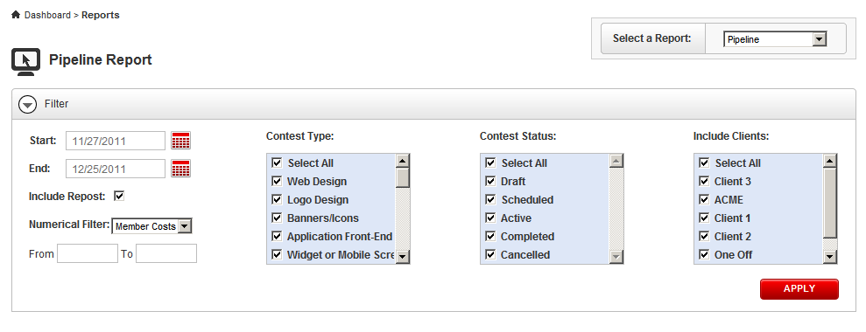

Increase your browser width to see wide version

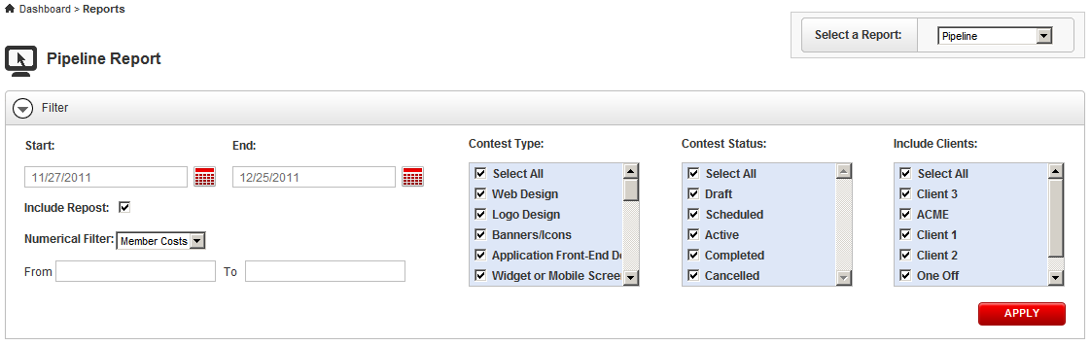

Choose a few options, and check apply

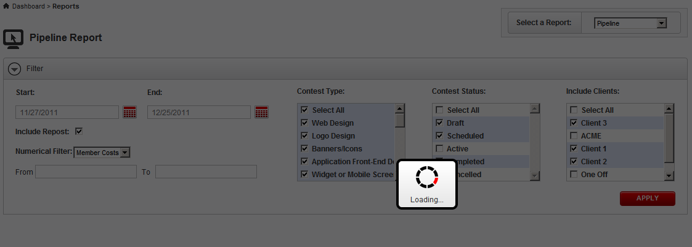

The report should be displayed after loading

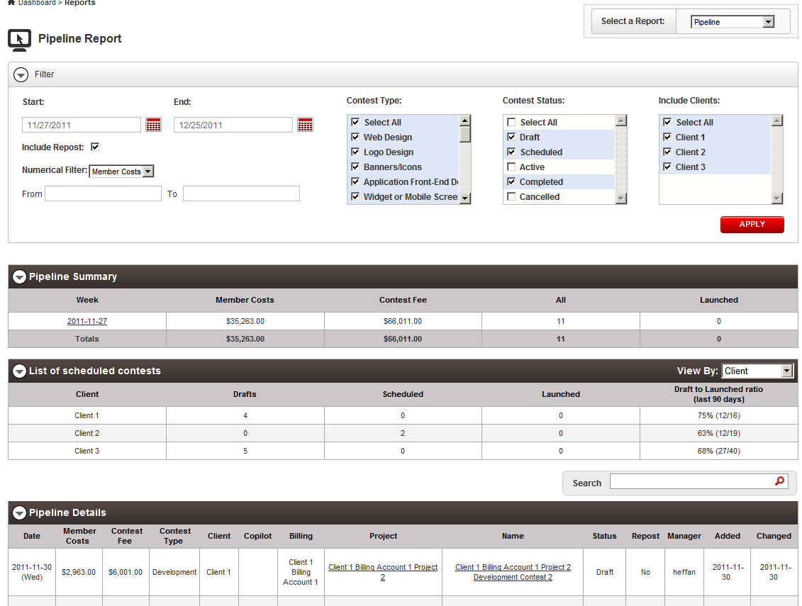

Now test the Numeric filter, add a numeric filter like the screenshot and click apply

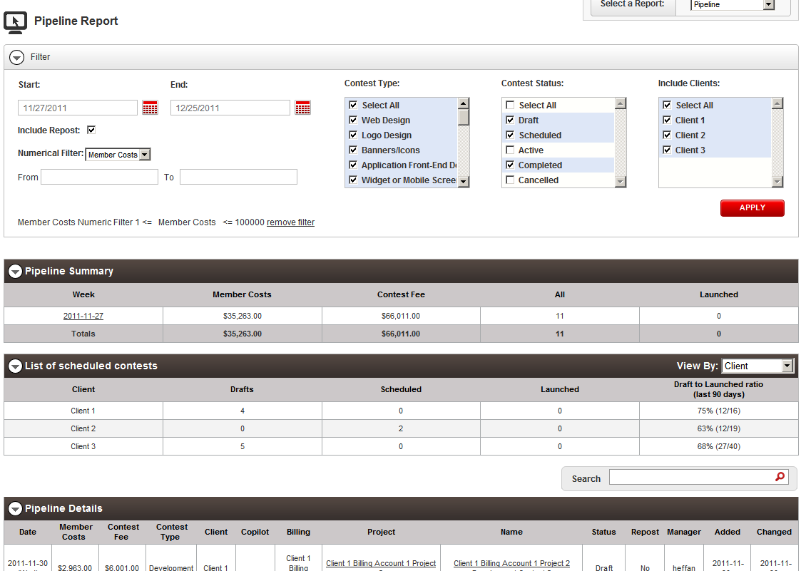

You can see the numeric filter is added to the filter panel, now add another numeric by choosing “Contest Fee” from the dropdown

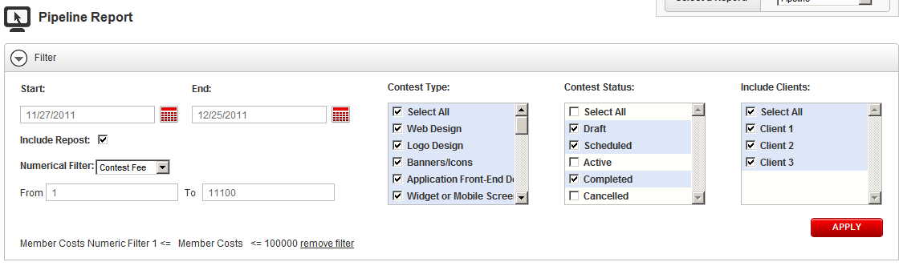

Click Apply to loading the report, and the new filter is applied upon current filter:

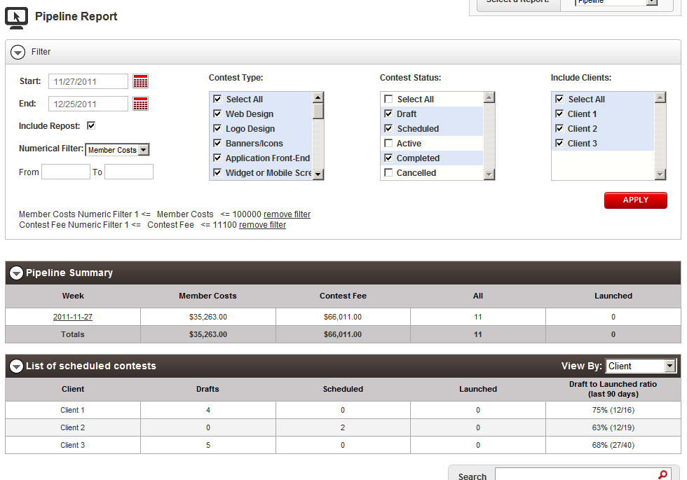

Now you can try removing the filter from filter panel by clicking ‘remove filter’

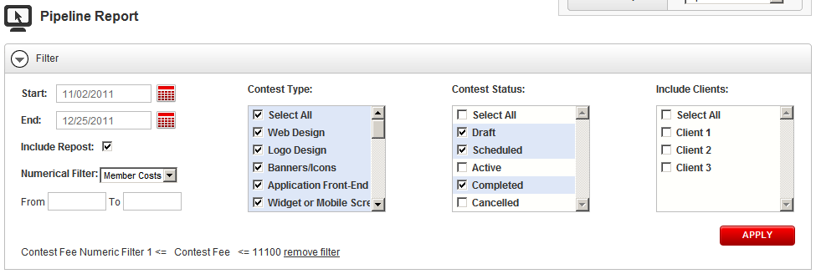

Now test the error handling of the pipeline report, choose a start date larger than the end date and click the apply button.

The validation error is displayed

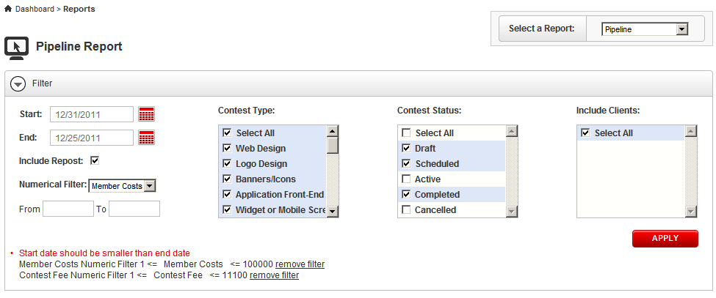

Enter a non-numeric value into the filter input box, and click apply

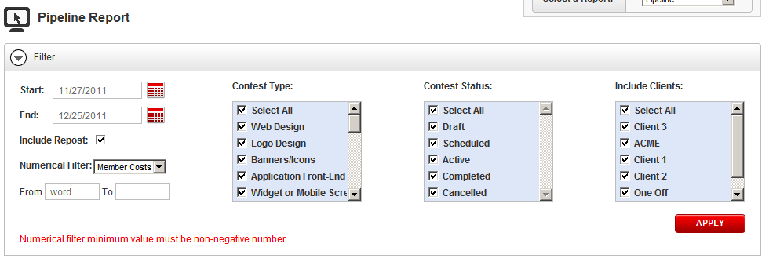

Cost Report Verification

Switch to the Cost Report by changing the right upper dropdown, you will see the cost report with new filter panel

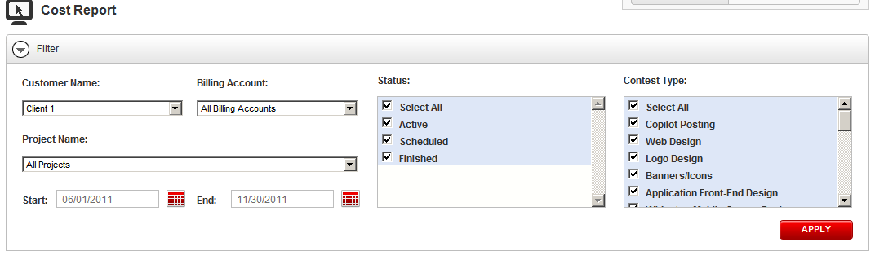

Change the browser width smaller to test the layout change
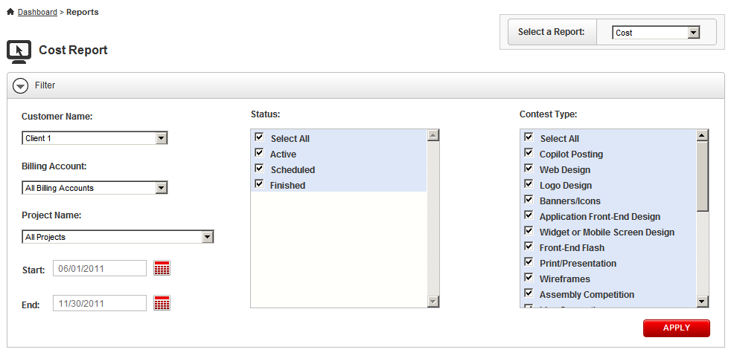

Test the error validation. Change the start date larger than the end date and click apply. The validation error should be displayed in the filter panel

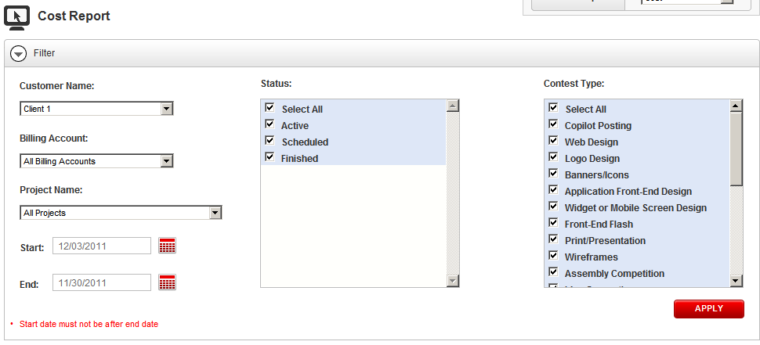

Test the dropdown. Change the customer name to Client 3

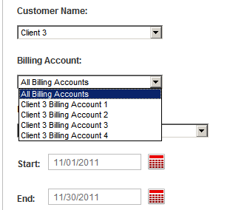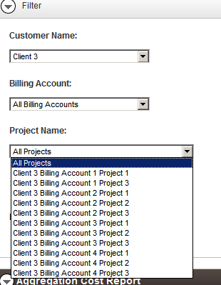

You can see the dropdowns of billing account and project name are updated.

Change the billing account to a specific one, the project name is updated

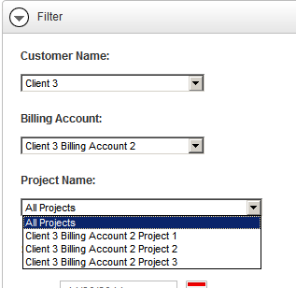

Click apply to see the report

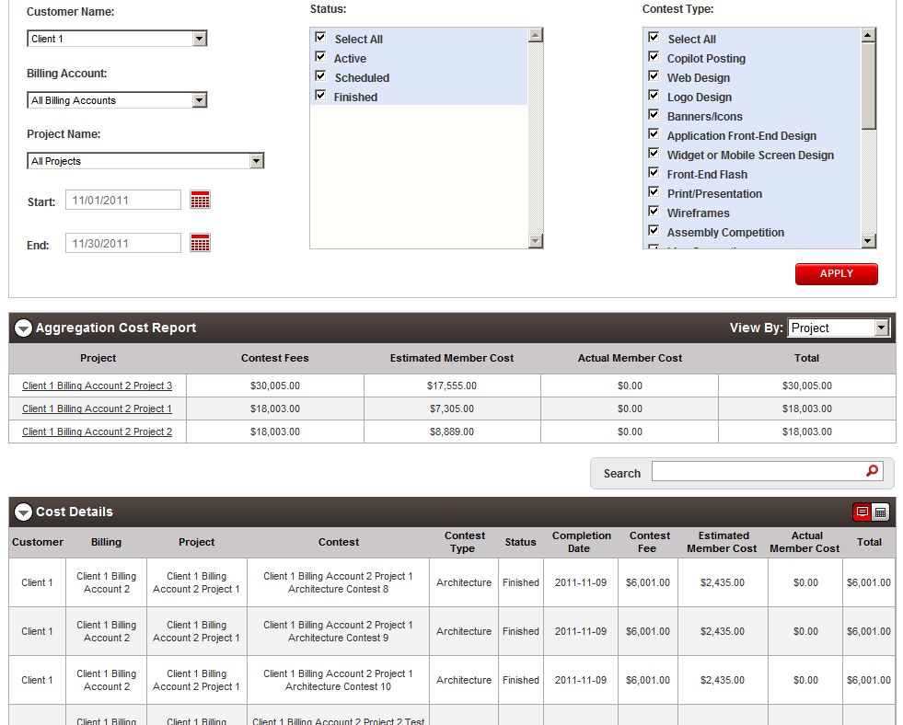

You can click the break down button in the cost report table to view break down view

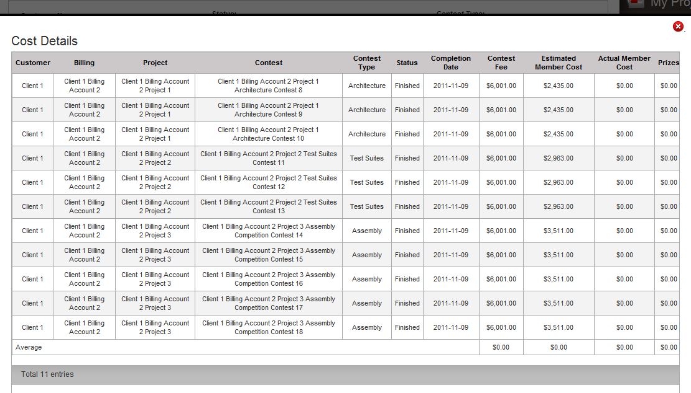

Close by right upper red button.

Billing Cost Report Verification

Change the dropdown to go to the billing cost report

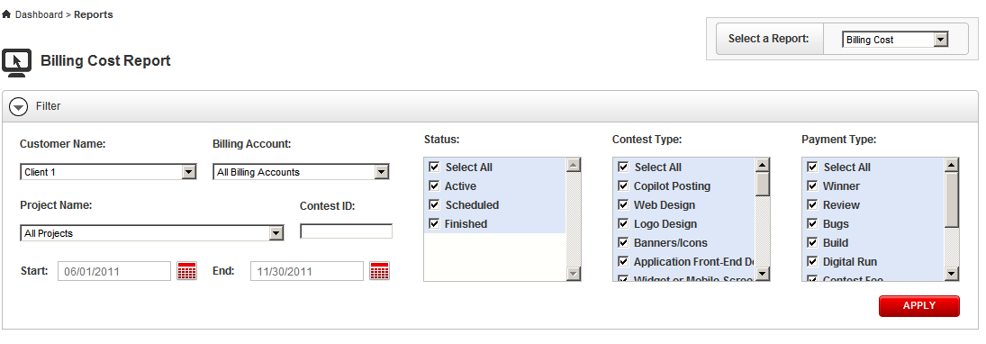

Change the browser width smaller to view the layout change

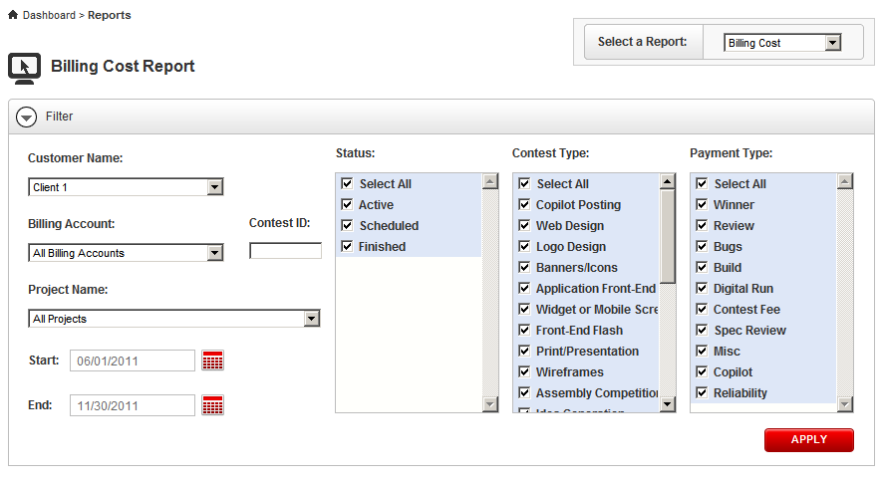

Test the error validation. Change the start date larger than the end date and click apply. The validation error should be displayed in the filter panel

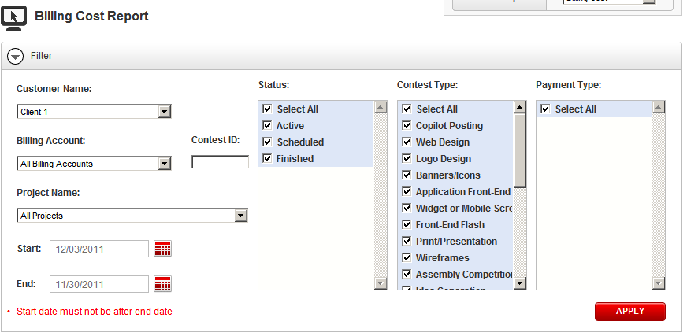

Test the dropdown changes:

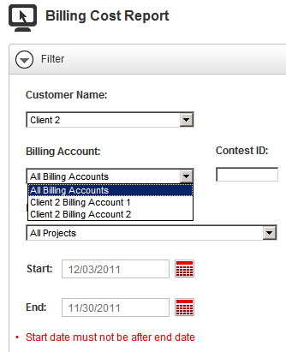

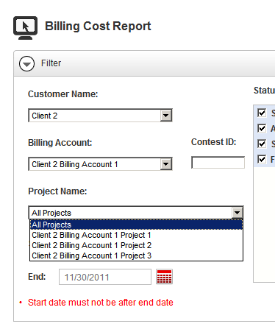

Click apply button to see the report

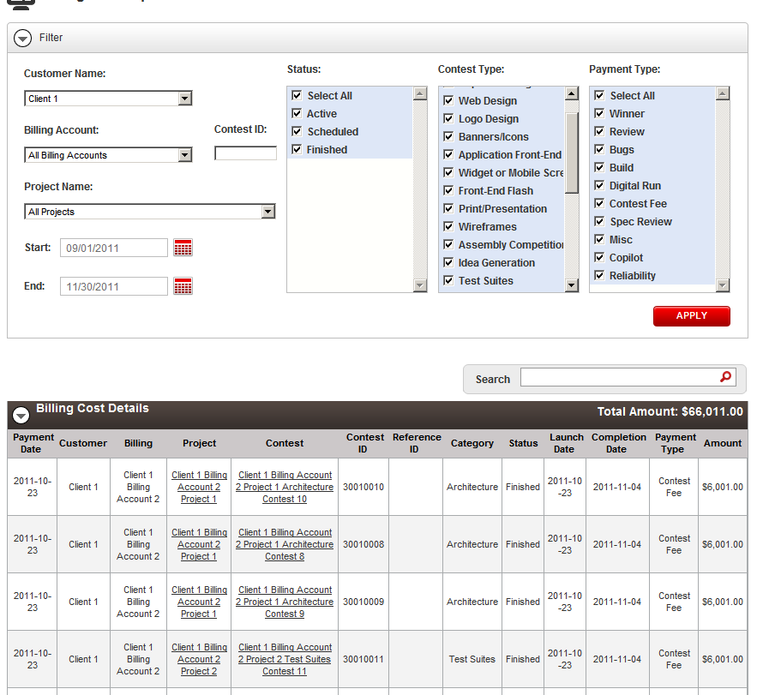

Test the contest ID with 30010010
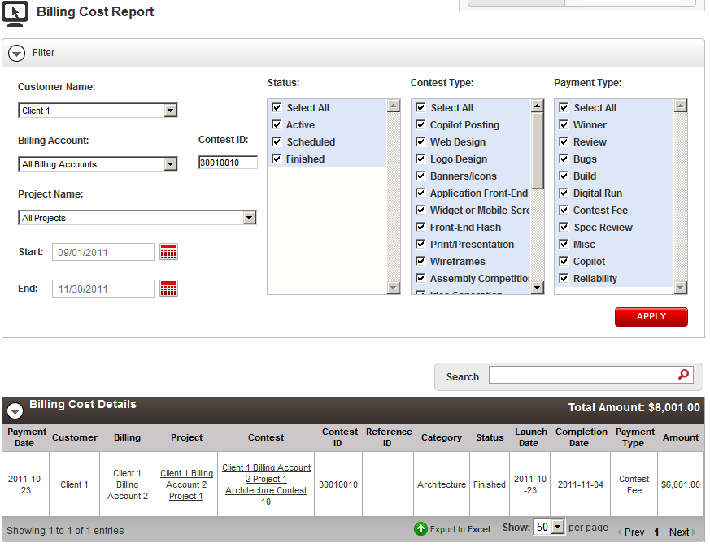

Resource Contact List

Name | Resource Email
TCSASSEMBER

